**HOTEL RENTAL MANAGEMENT**

**Screen Shots for the project**

**WELCOME SCREEN:**

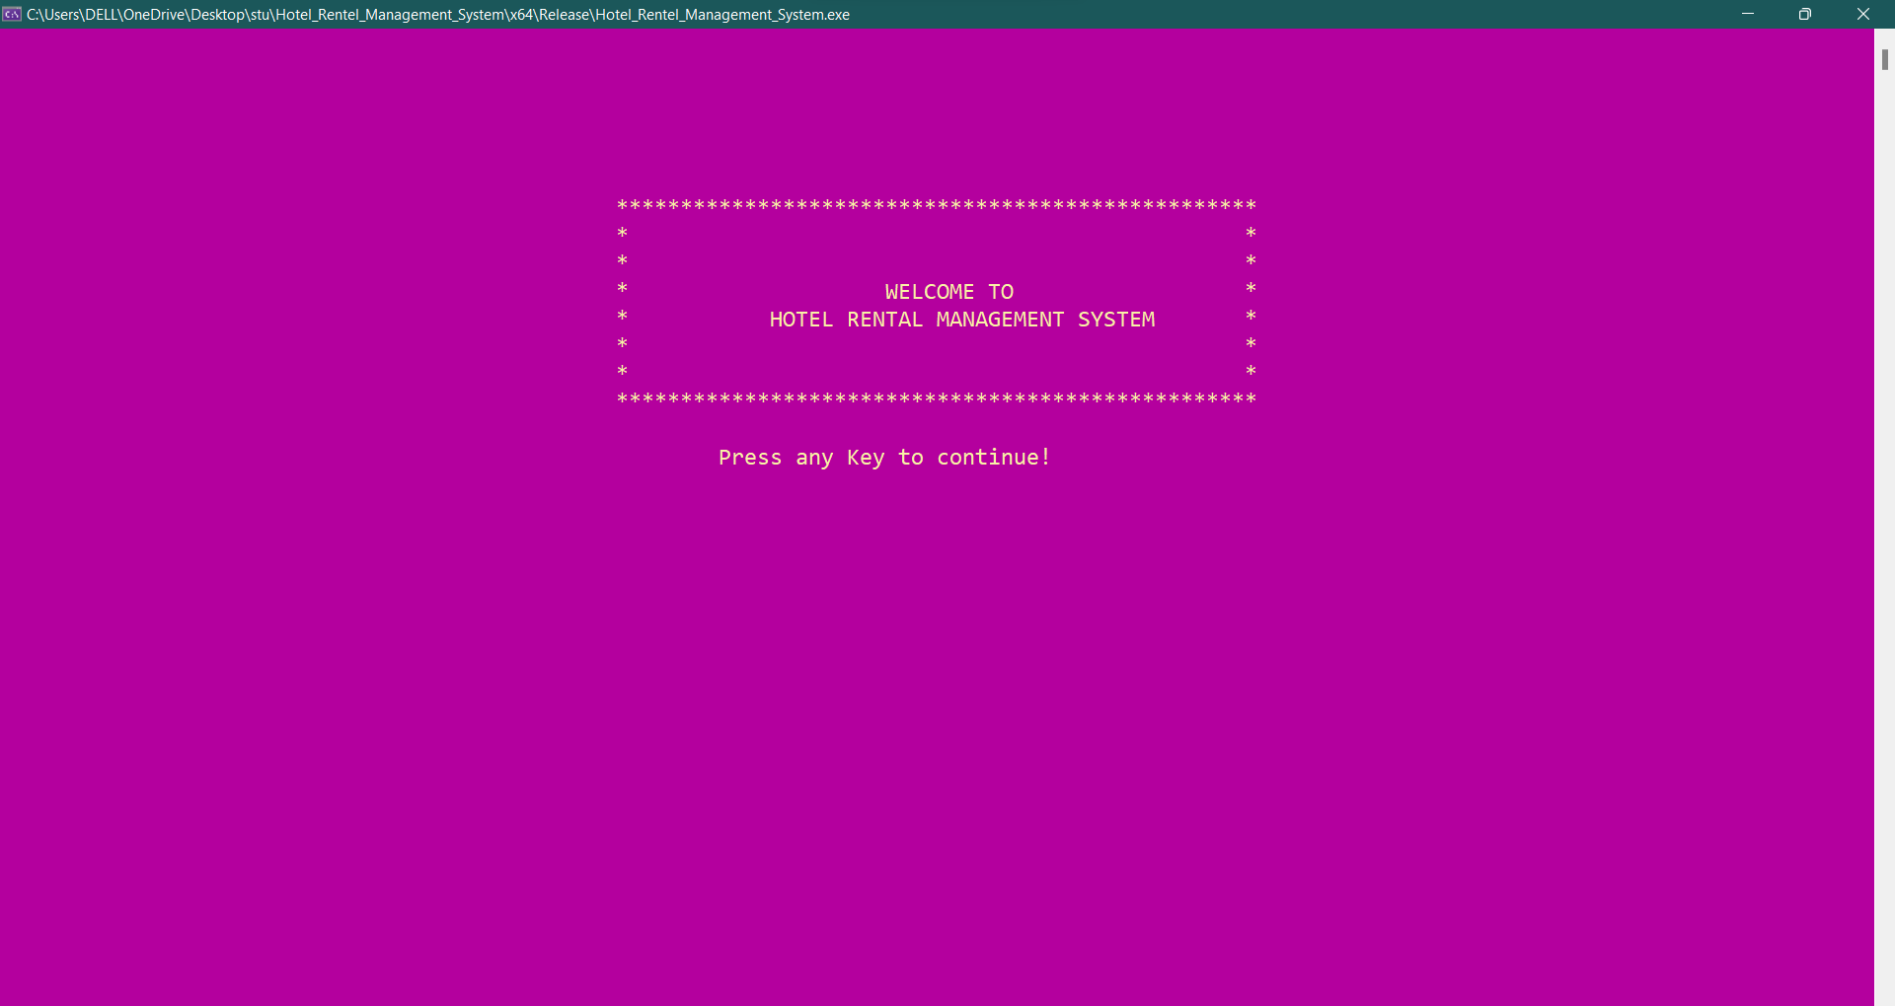

**LOGIN SCREEN:**

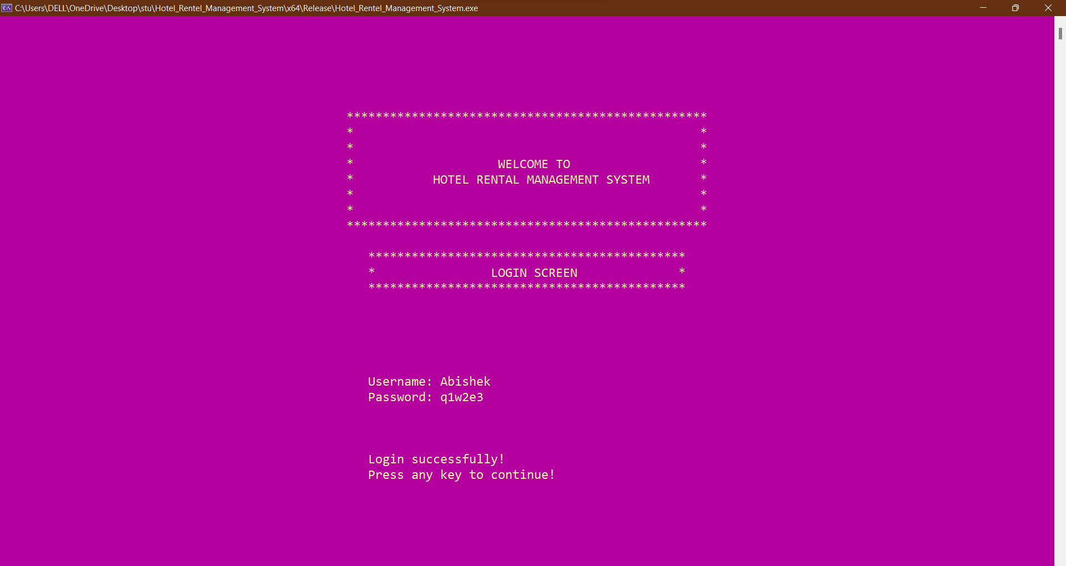

Login details in Login_credentials Table:

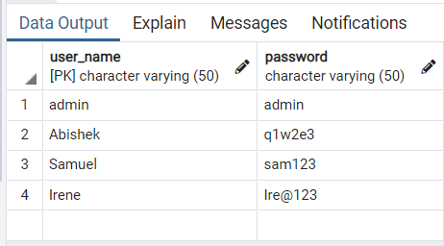

**MAIN SCREEN**

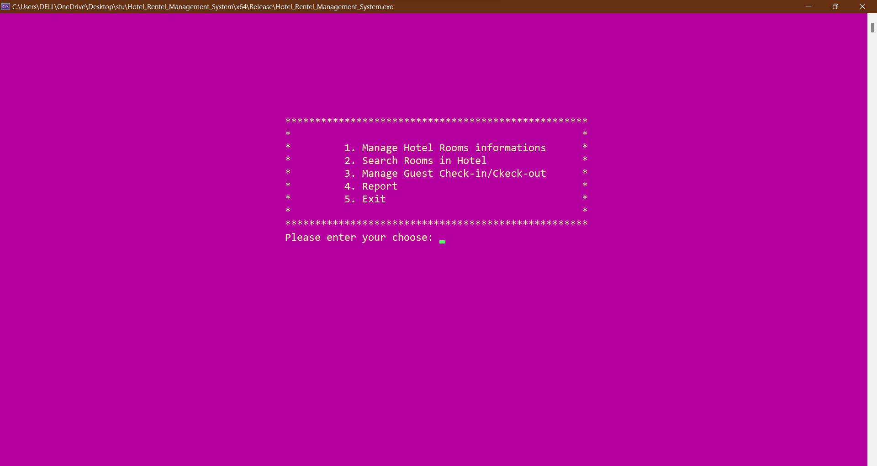

**On Pressing 1. Manage Hotel Rooms Information**

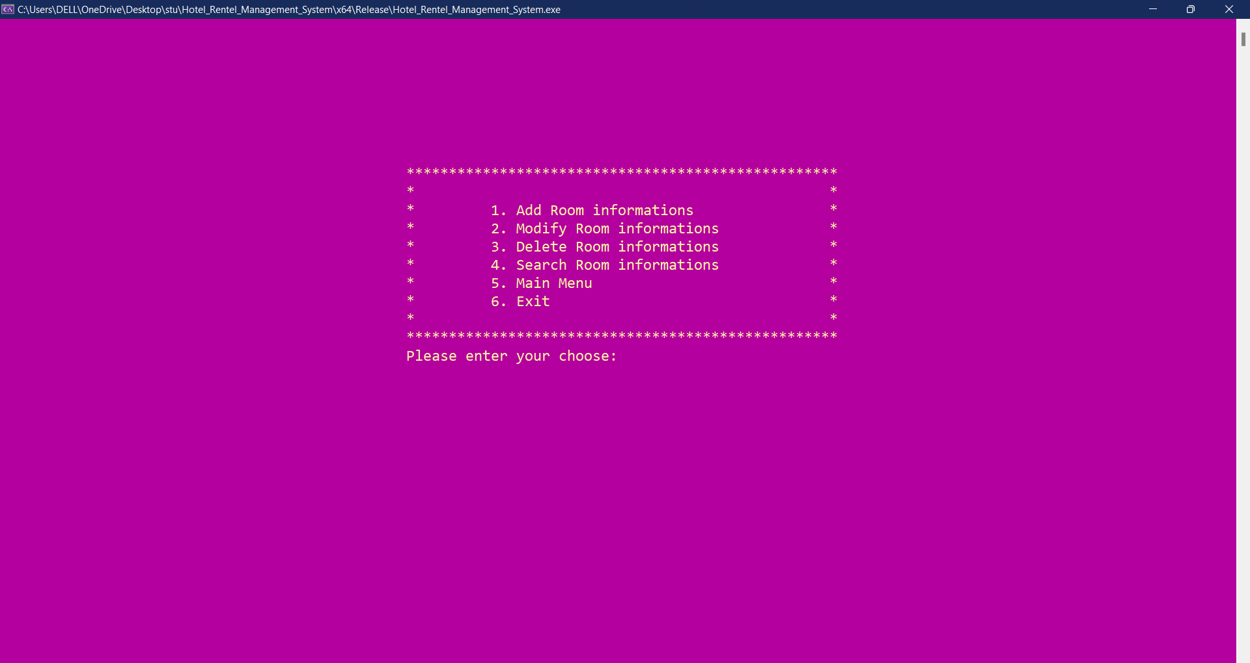

**CRUD OPERATIONS IN ROOM’S MANAGEMENT**

**Inserting** Room Information into Database:

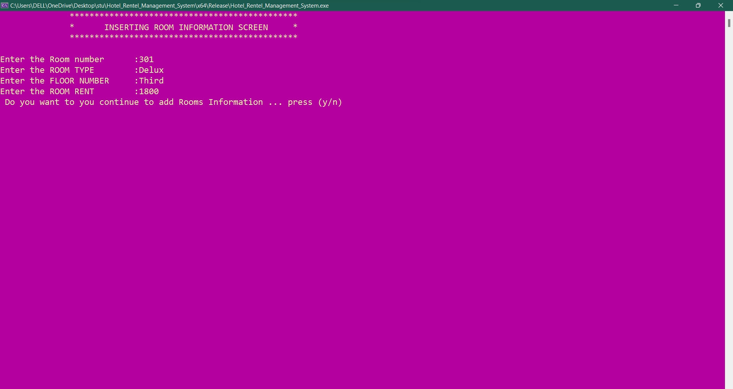

**Hotel Rooms Information in table after inserting:**

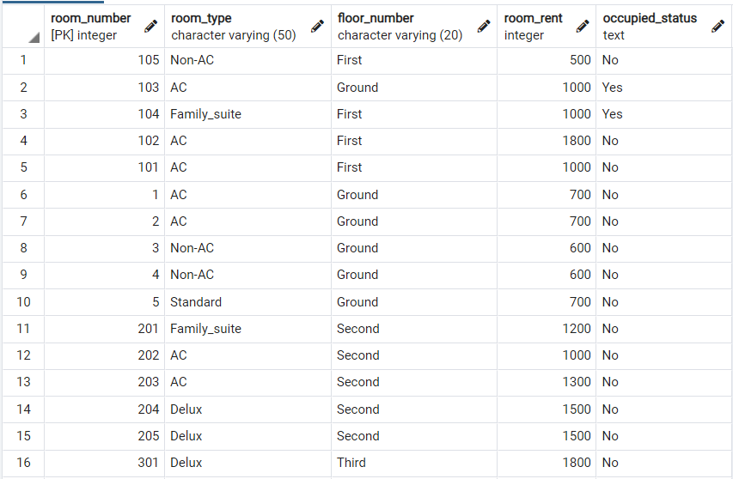



Updating Room Information into Hotel_room_info Table:

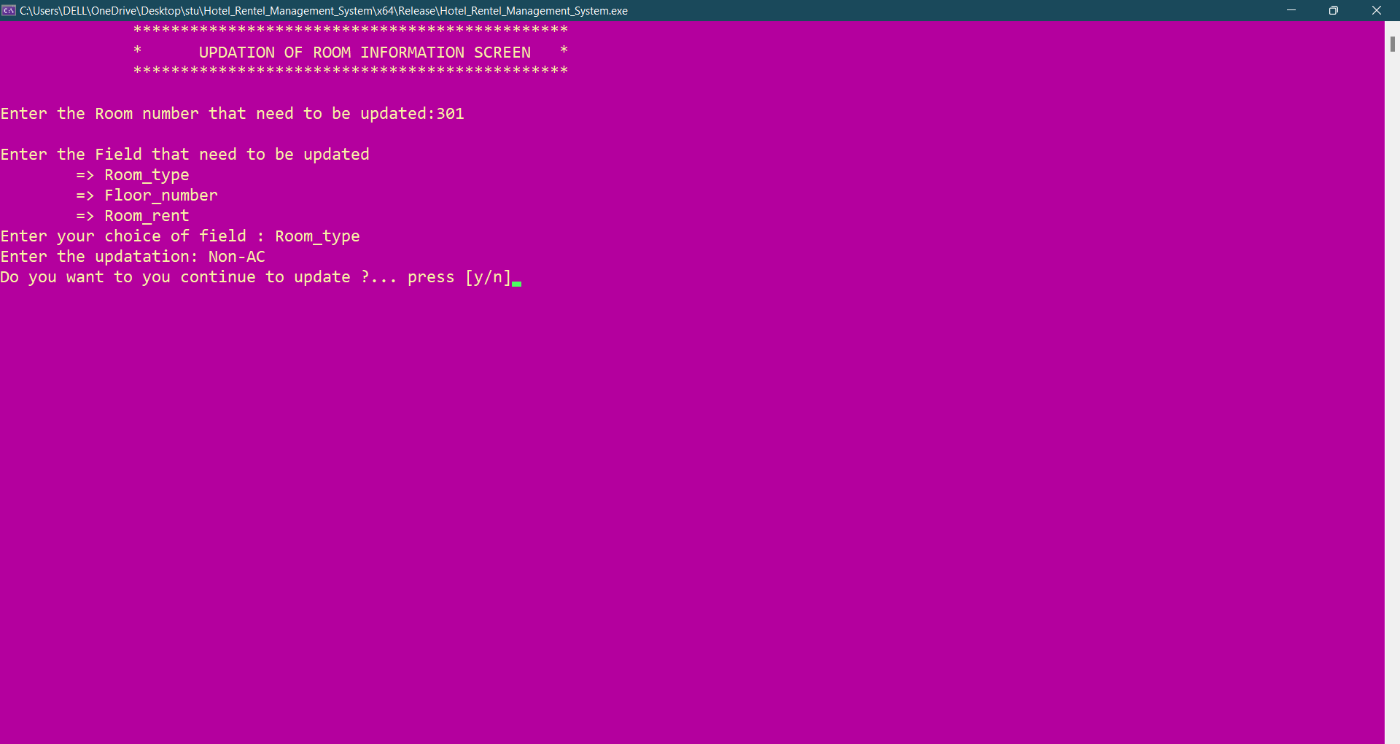

**Hotel Rooms Information in table after Updating:**



**Deleting Rooms Information:**

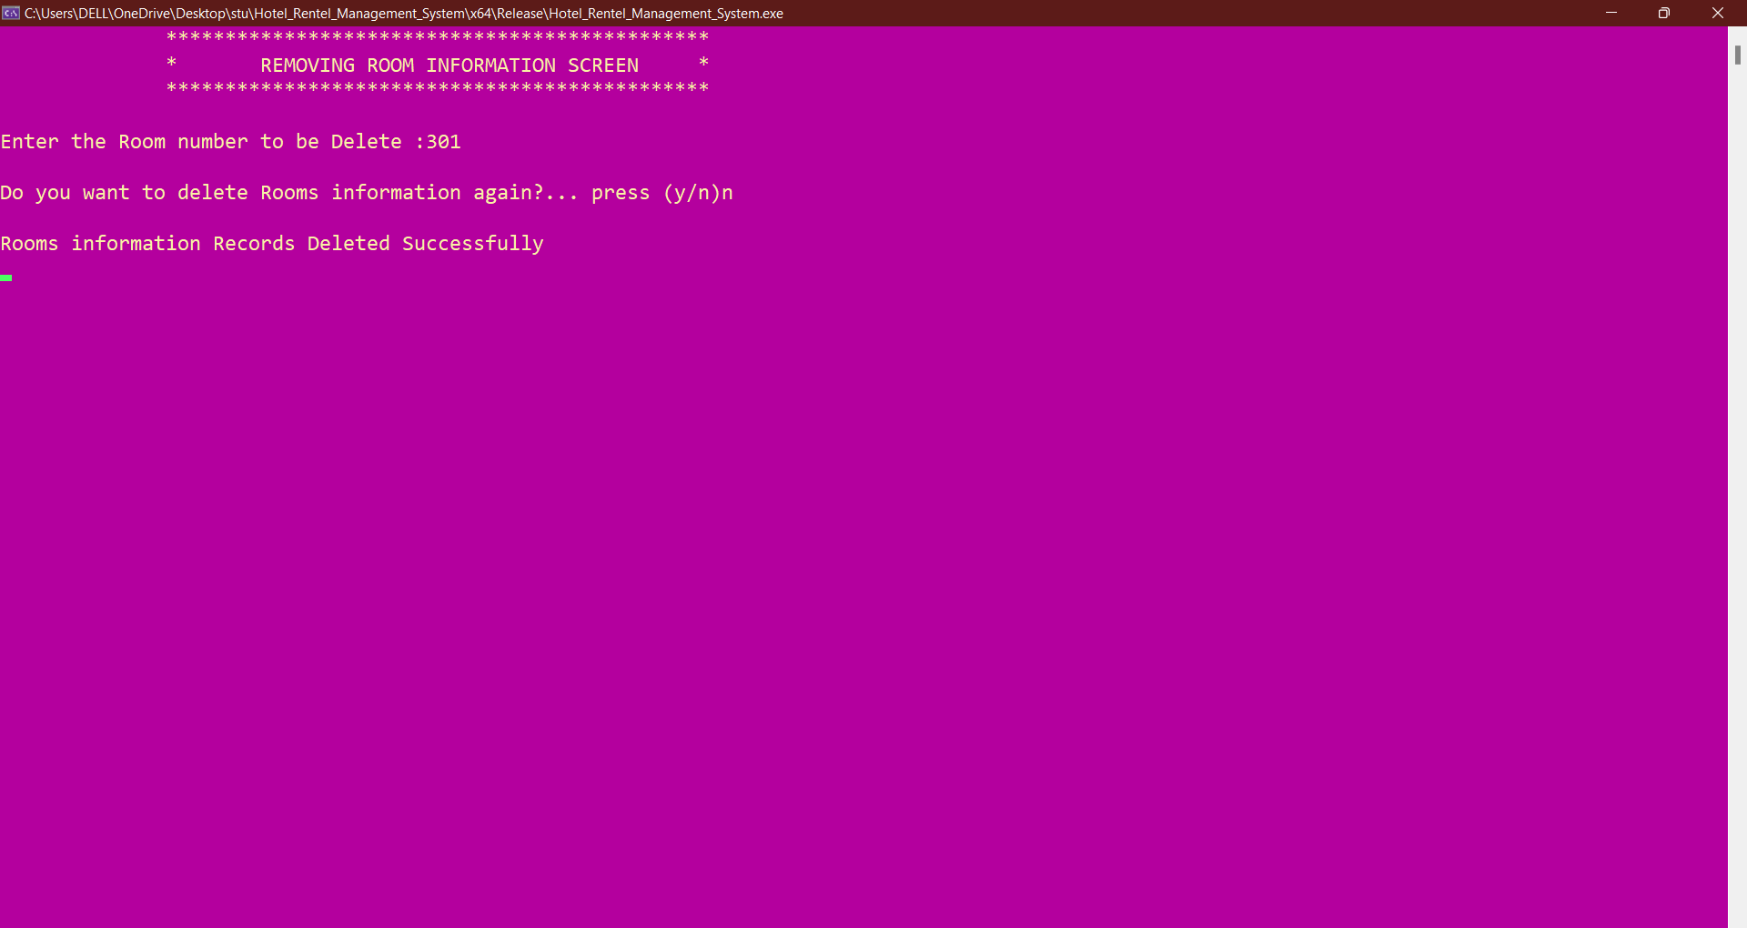

**Hotel Rooms Information in table after deleting Room .301:**

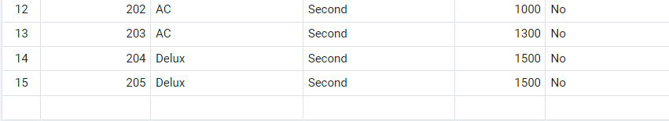

**Room Information:**

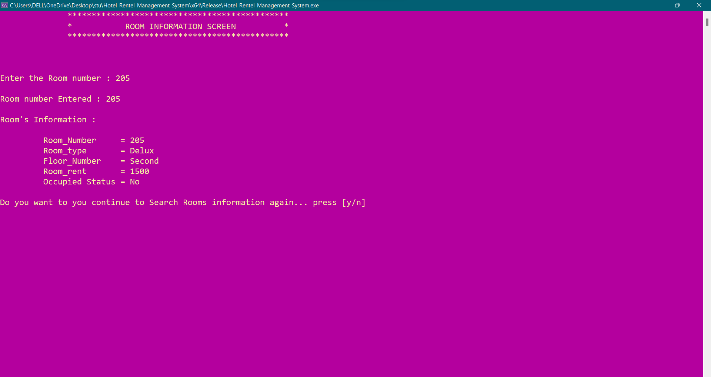

The above screen describes the search room information ( hotel_room_info table ) according to the room number to check whether the room is vacant or occupied .

**Main Menu Screen:**

On Pressing 2 . 🡪SEARCH ROOMS IN HOTEL:

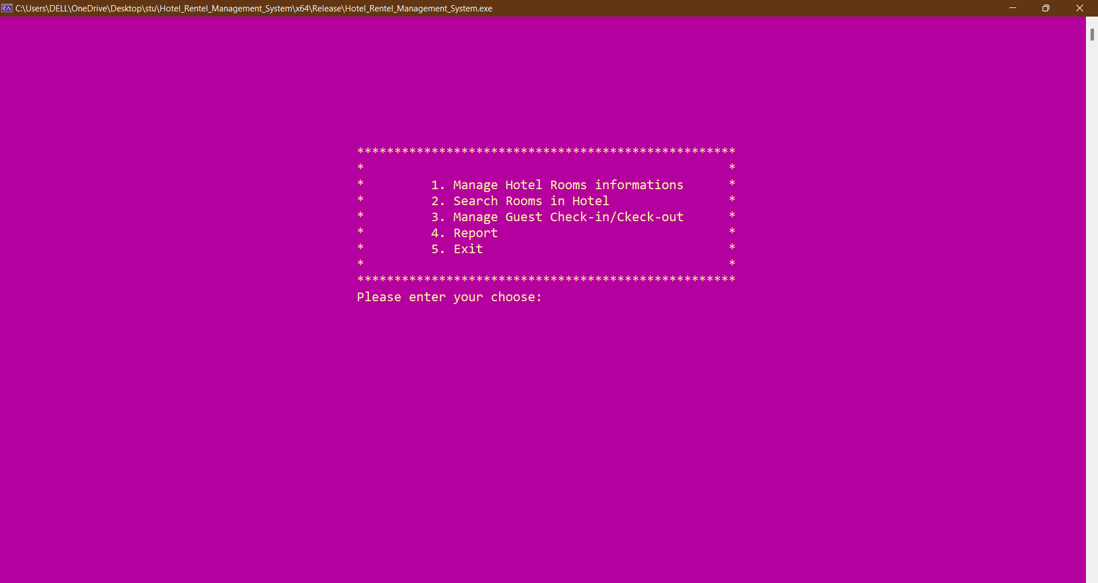

**Search Main Screen:**

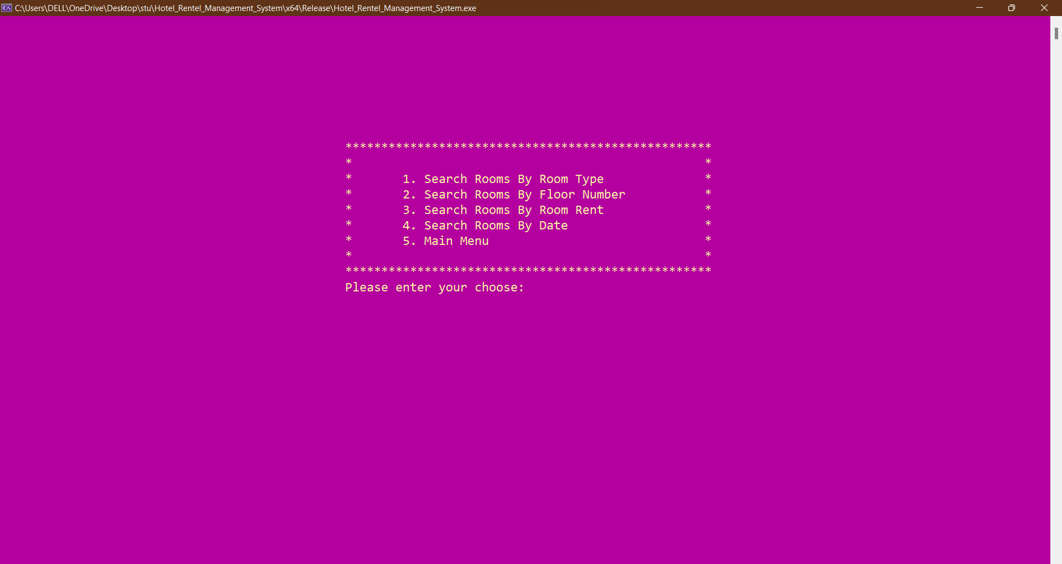

**On Pressing 1.** 🡪 **Search Rooms According to ROOM TYPE:**

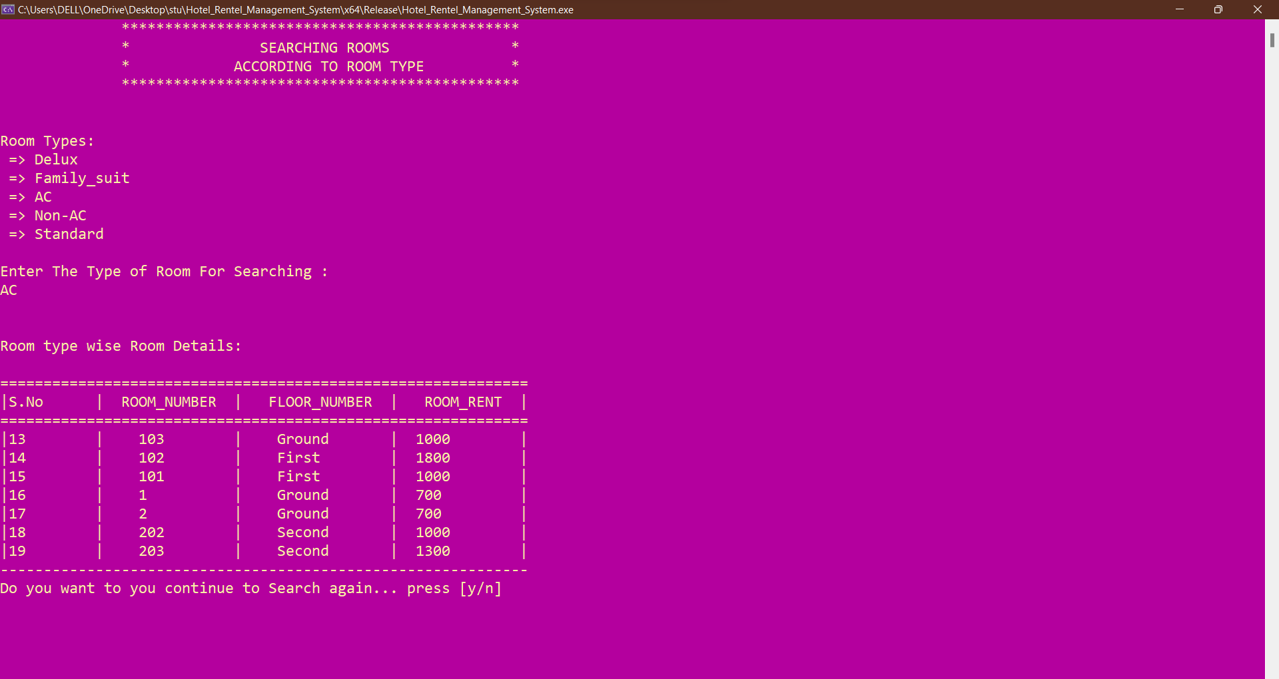

**ROOM TYPE Search in Hotel_room_info Table:**

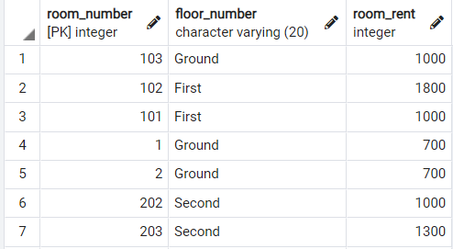

**On Pressing 2.** 🡪 **Search Rooms According to FLOOR NUMBER:**

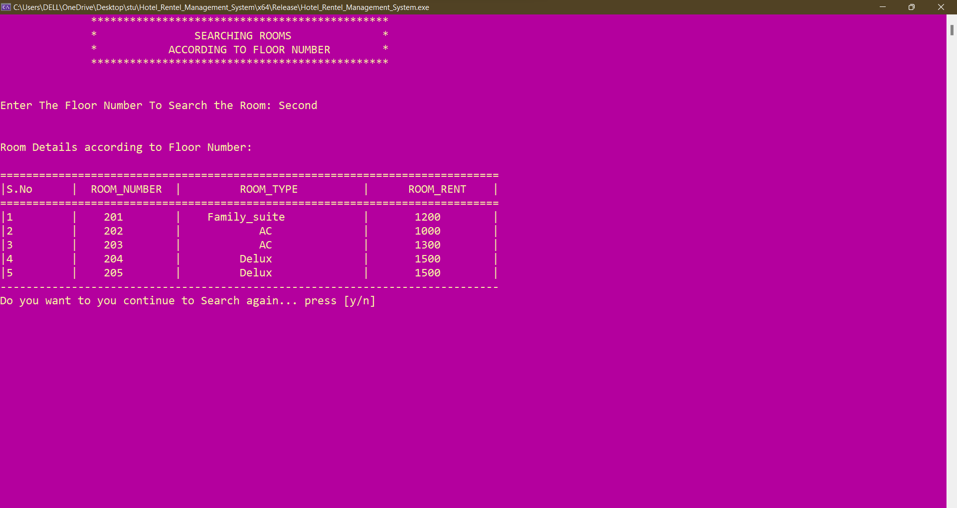

FLOOR NUMBER Search in Hotel_room_info Table:

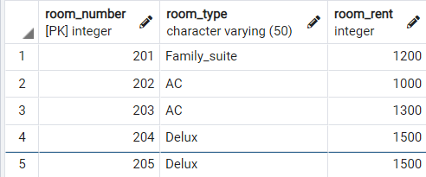

**On Pressing 3.** 🡪 **Search Rooms According to Room Price Range**

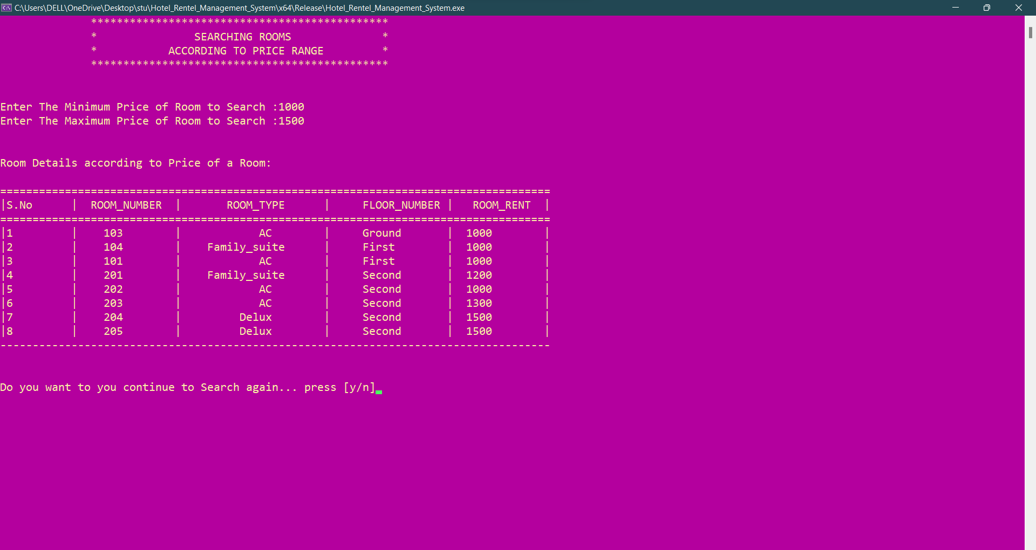

**Room Rent Price-Range Search in Hotel_room_info Table:**

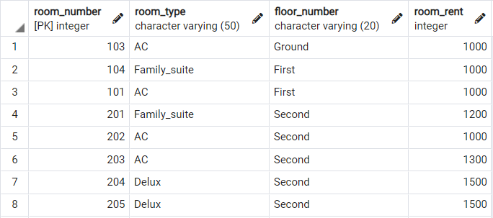

**On Pressing 4.** 🡪 **Search Rooms According to Date of Check-In**

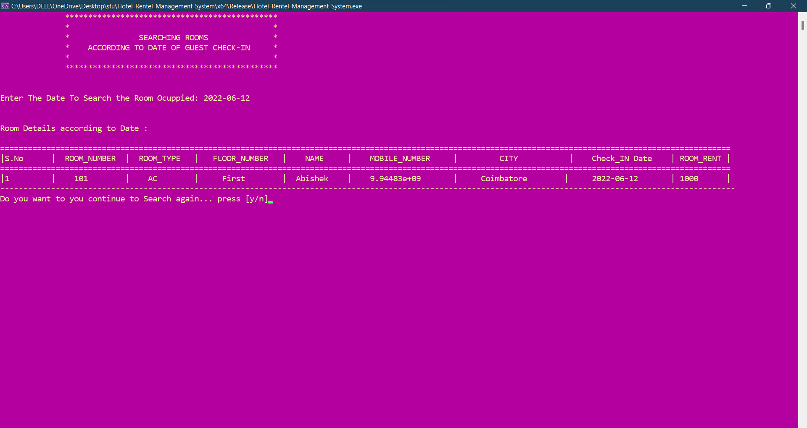

**Check-In Date Search in Hotel_room_info Table:**



**MAIN MENU SCREEN**

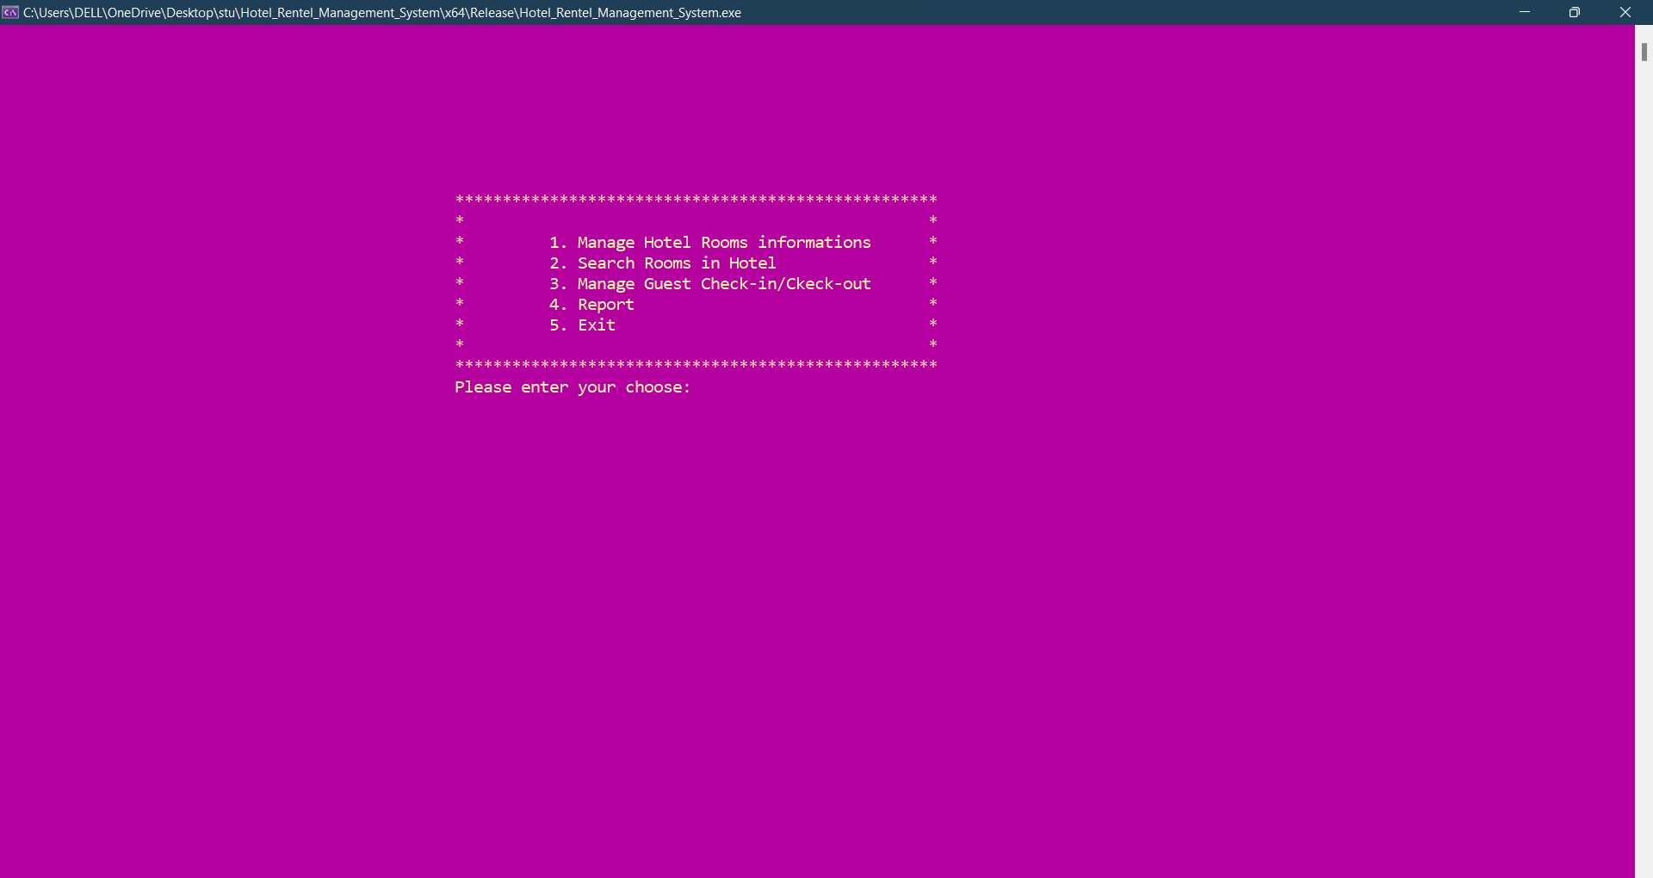

**On Pressing 3.** 🡪 **Manage Guest Check-In/ Check-Out :**

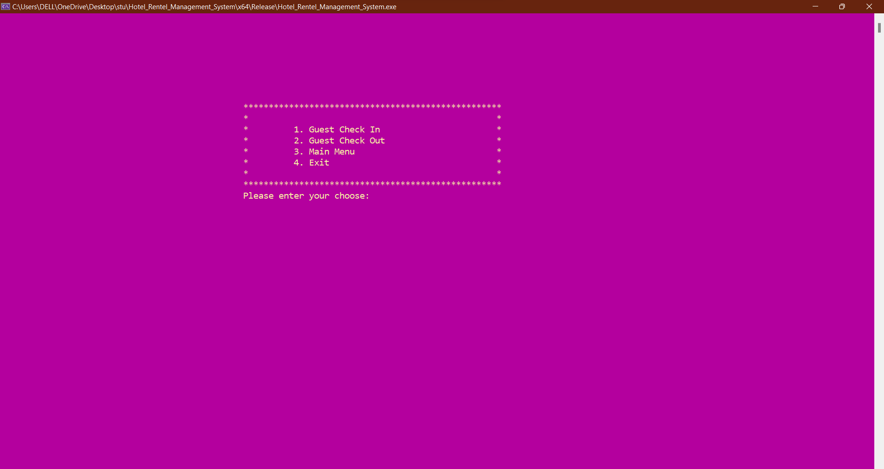

**On Pressing 1.** 🡪 **Guest Check-In =>Allotment of Room for Guest Screen:**

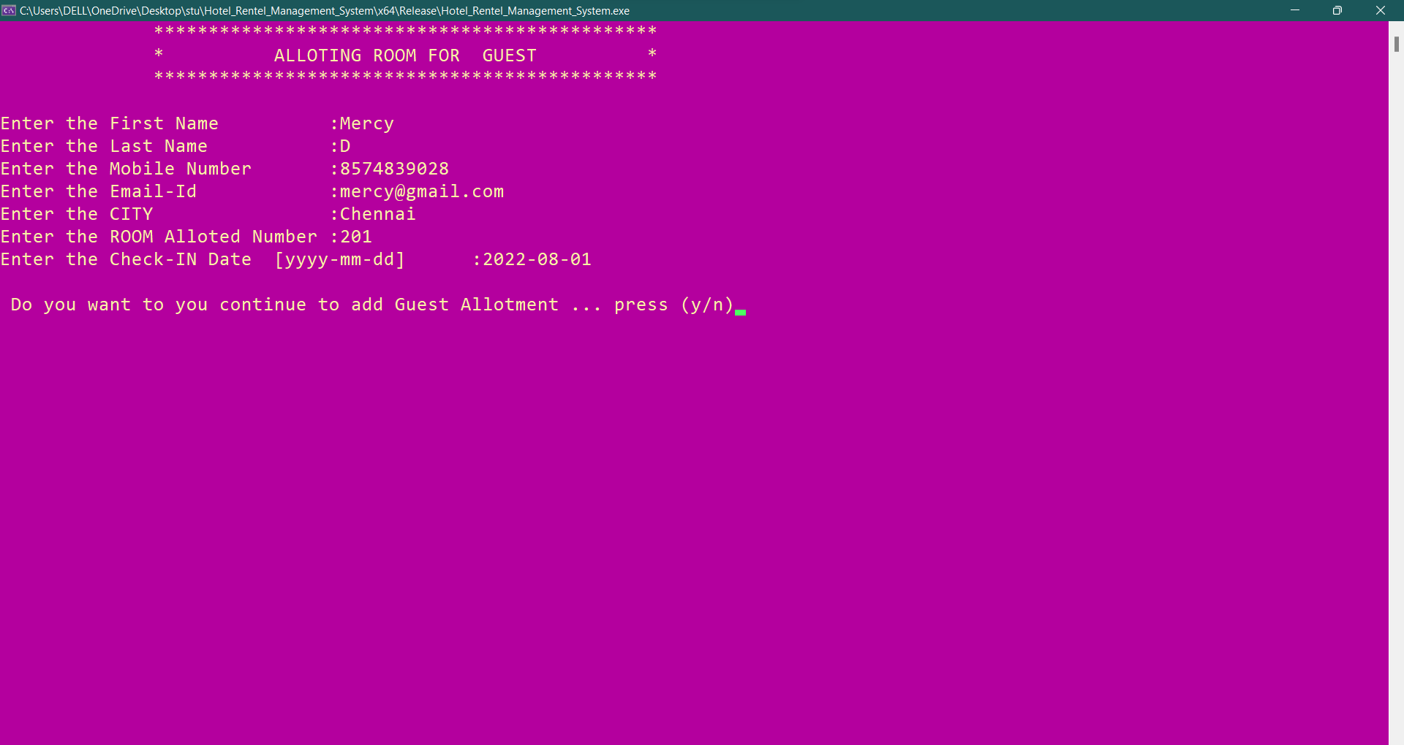

Allotment of Room for Guest :

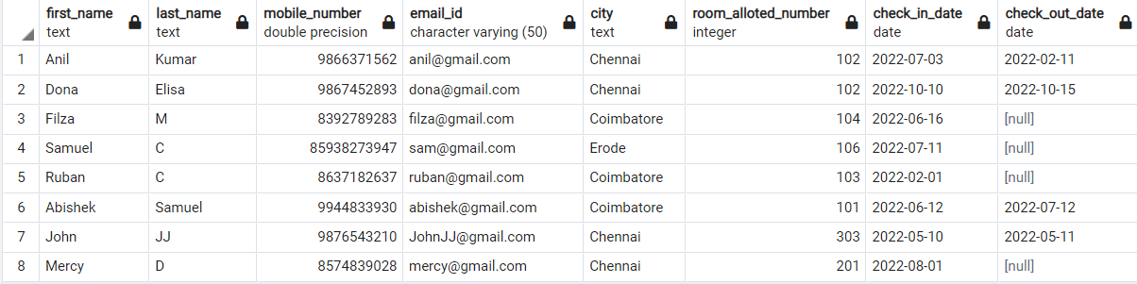

In the Table [null] is given because the guest still didn’t check-out.

**On Pressing 2.** 🡪**Guest Check-Out Screen:**

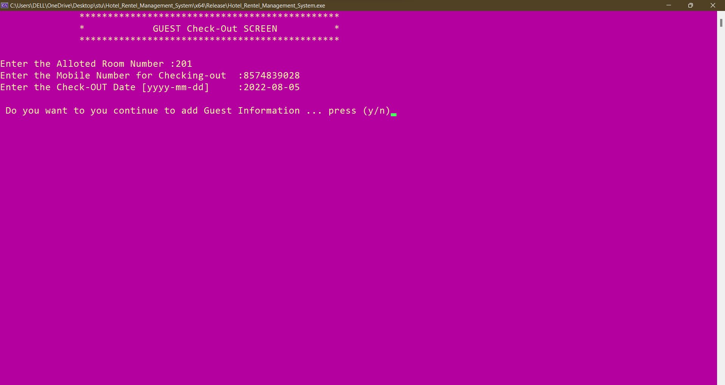



**MAIN MENU SCREEN:**

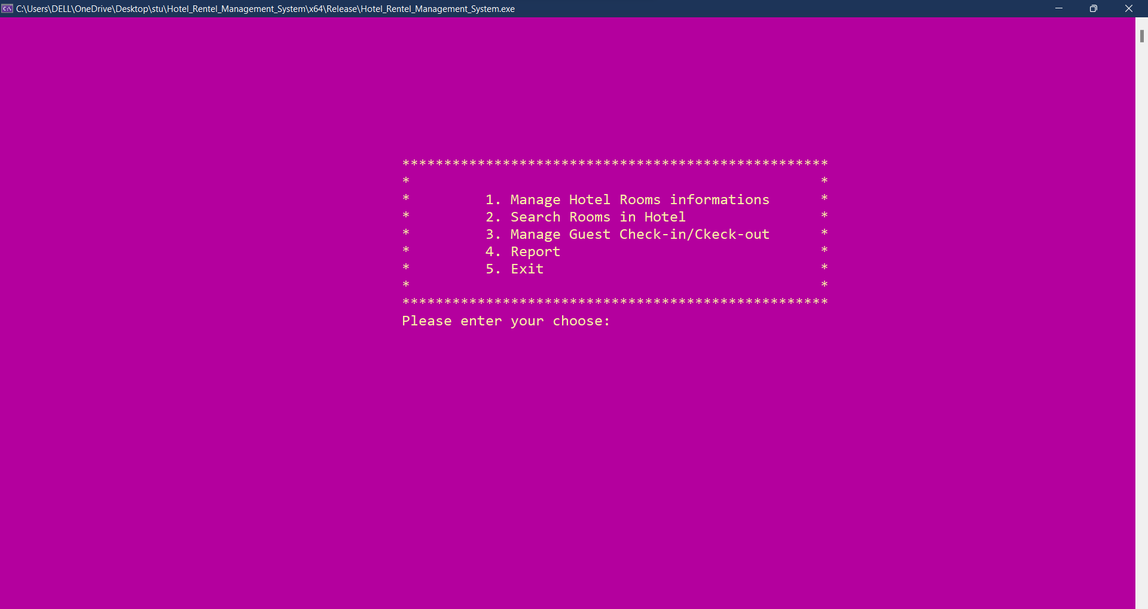

**On Pressing 4 =>Report Menu Screen(Report)**

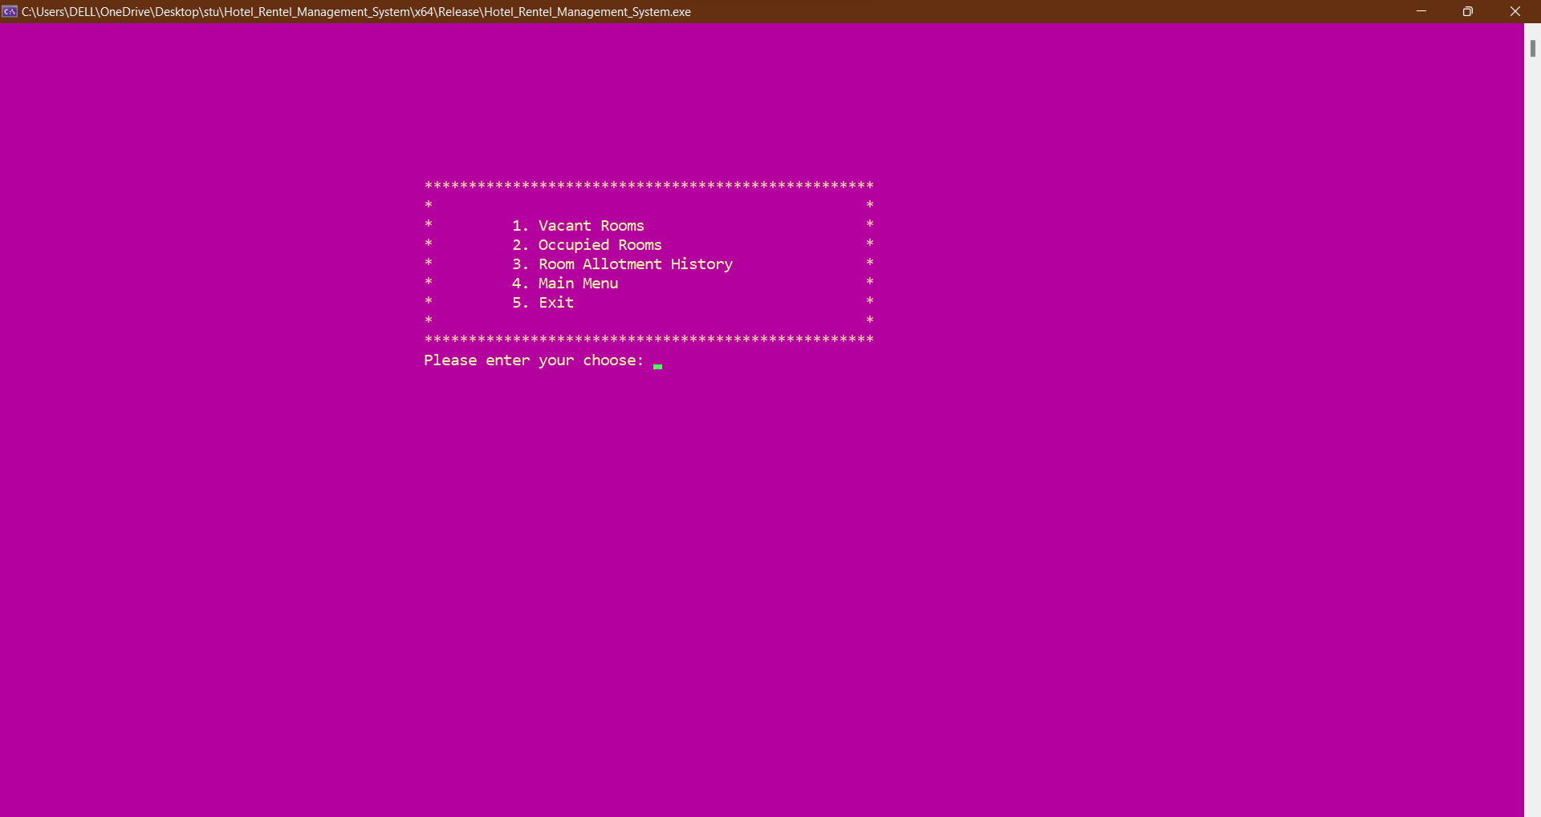

**On Pressing 1 => Vacant Rooms Available(Report)**

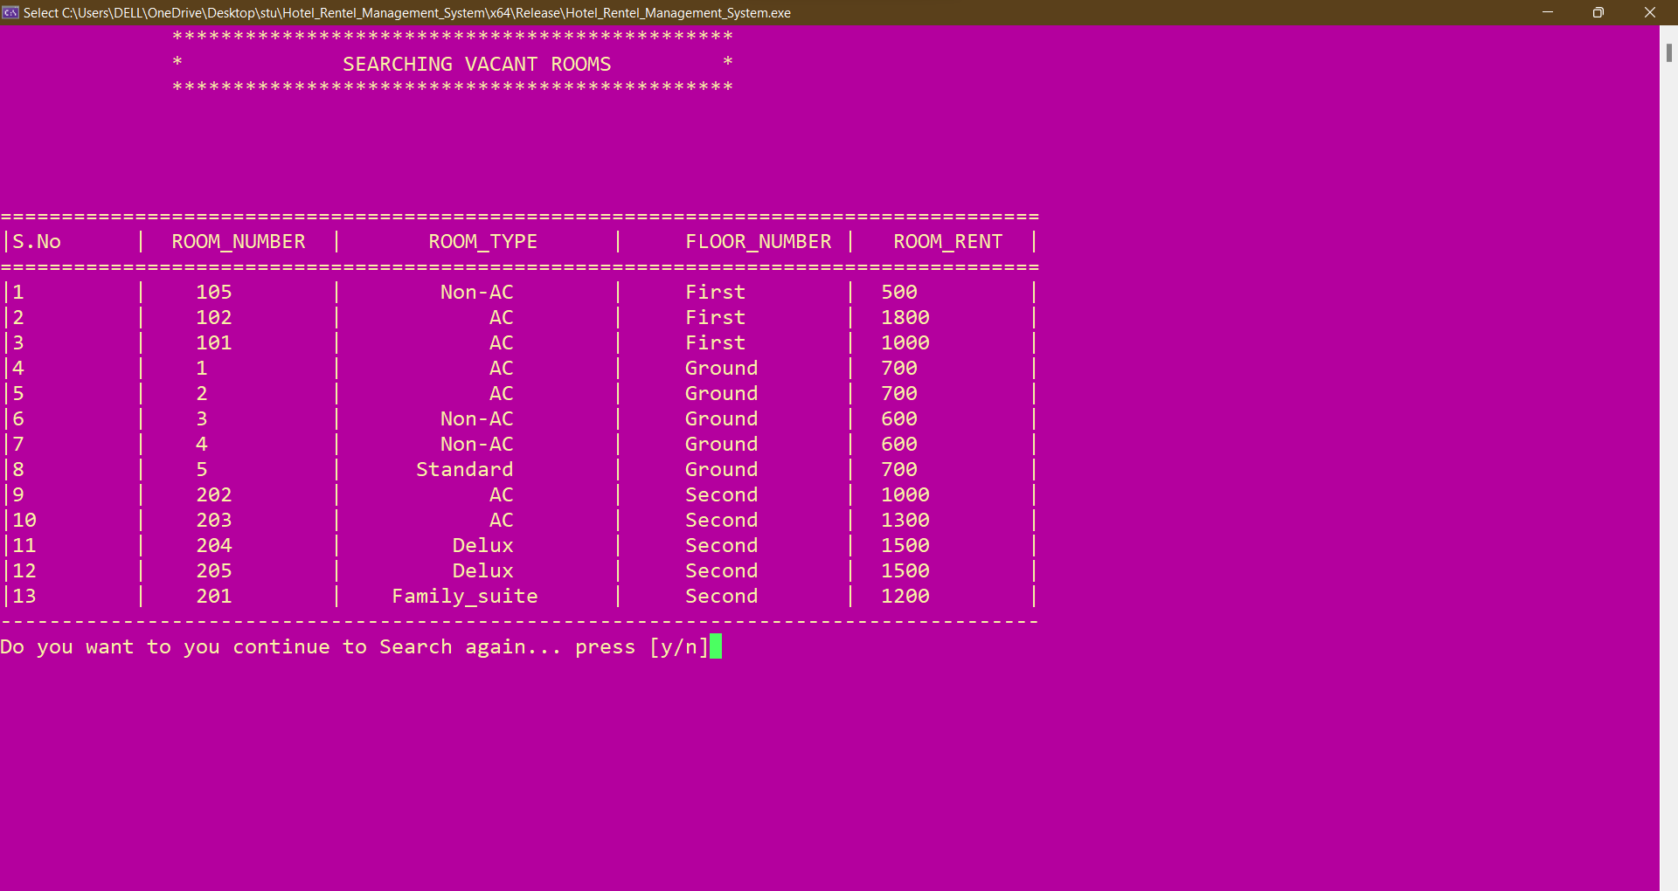

**On Pressing 2 => Occupied Rooms(Report):**

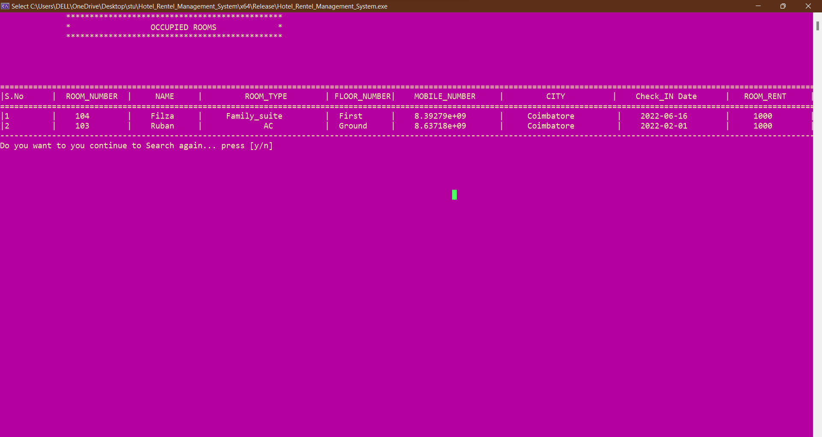

**On Pressing 3 => Room Allotment History(Report)**

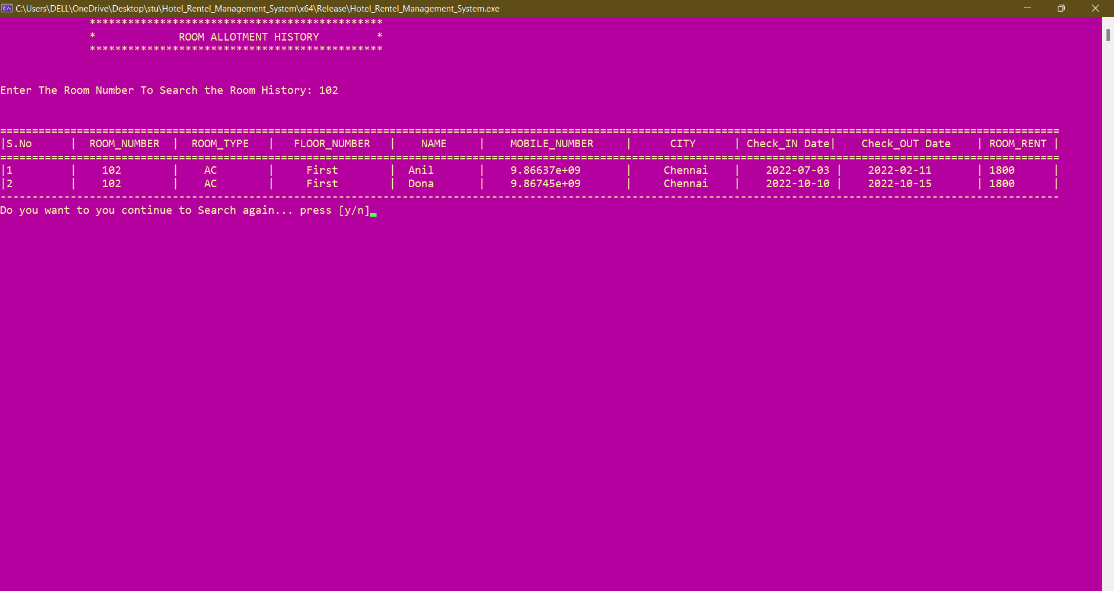

**EXIT SCREEN:**

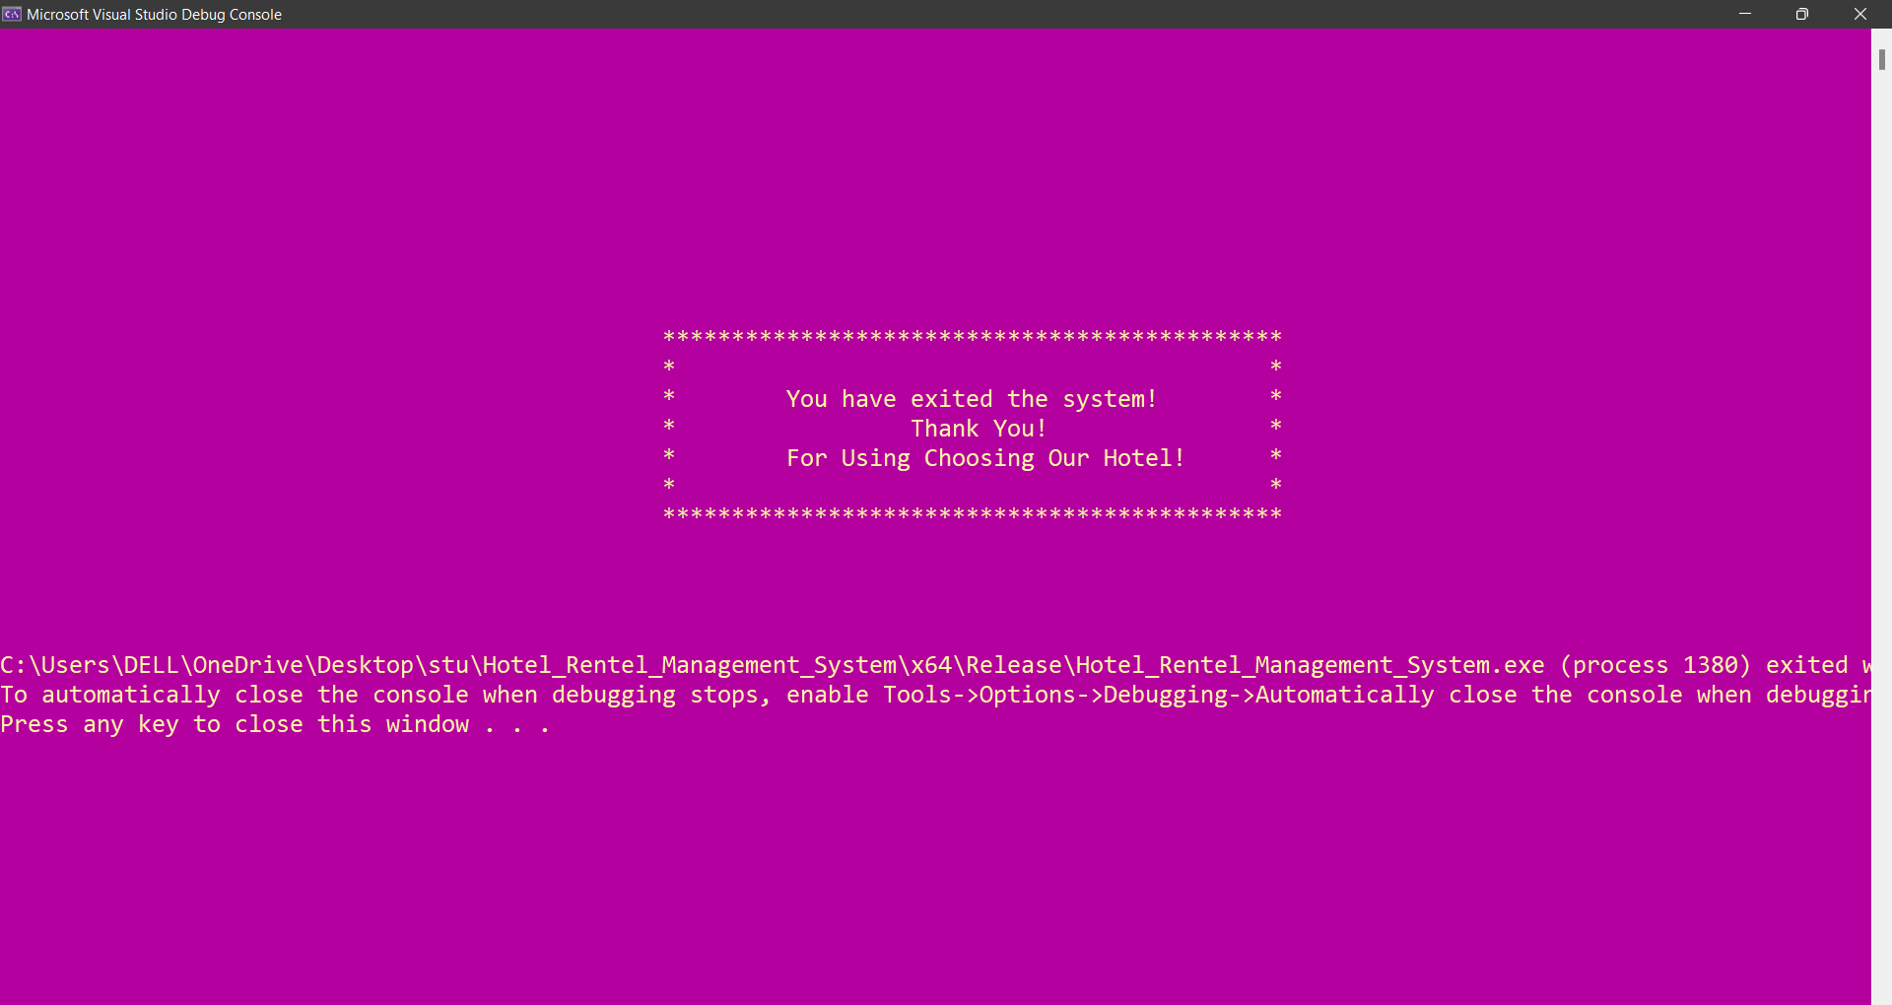

Thanking you

Abishek Samuel